**Project 3**

Group: Dan T Do, Felix Ponley, Lucas Vianna

Proposal

Summary: Our Project 3 will be a data visualization of life expectancy as it relates to a country's GDP per capita from 1998-2018. Our data will be gathered from ourworldindata.org, a website that contains various data sets that focus on inequality around the globe. We will manipulate the raw data and perform ETL utilizing SQL. Also, our visualizations will be created using HTML/CSS. Ideally, our project will deploy to a dashboard page that contains our three visualizations, with all of the data coming from the GDP per capita and life expectancy dataset. Our dataset contains over 5000 records, thus being of sufficient length for this project. The three visualizations that we will create from our dataset will be user-friendly and will contain menus and drop-downs that can be interacted with.

Topic: Life expectancy

Dataset :

Life Expectancy vs GDP per Capita <https://ourworldindata.org/life-expectancy#life-expectancy-and-gdp>

Link to the GitHub repository:

<https://github.com/Lucasmvs1994/Project_3>

Screenshot of the Metadata:



Inspiring visualizations:

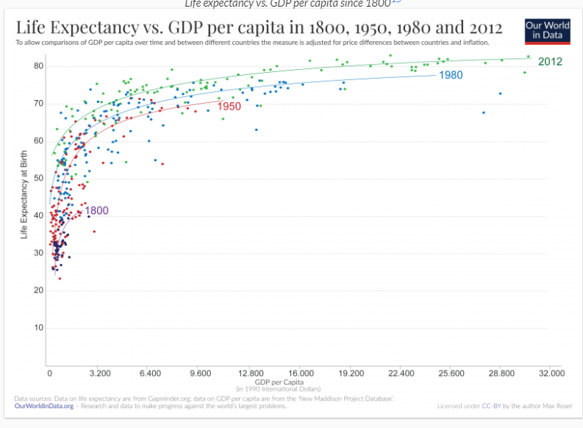

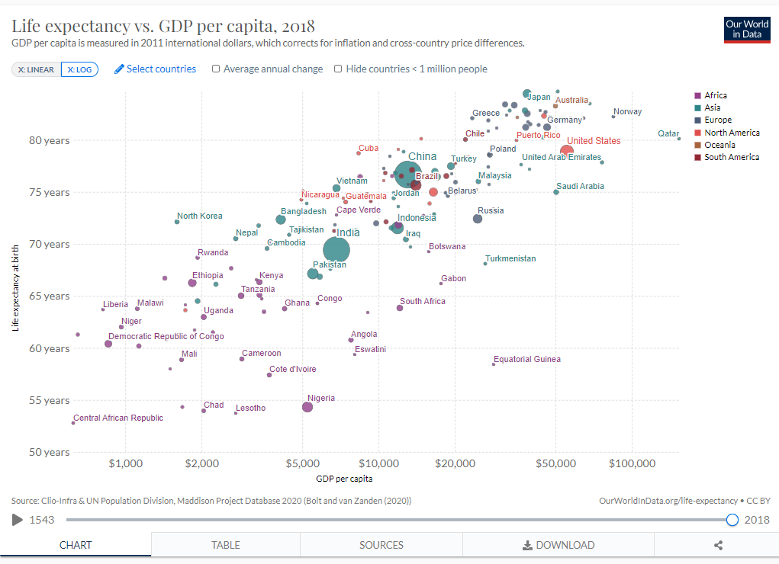

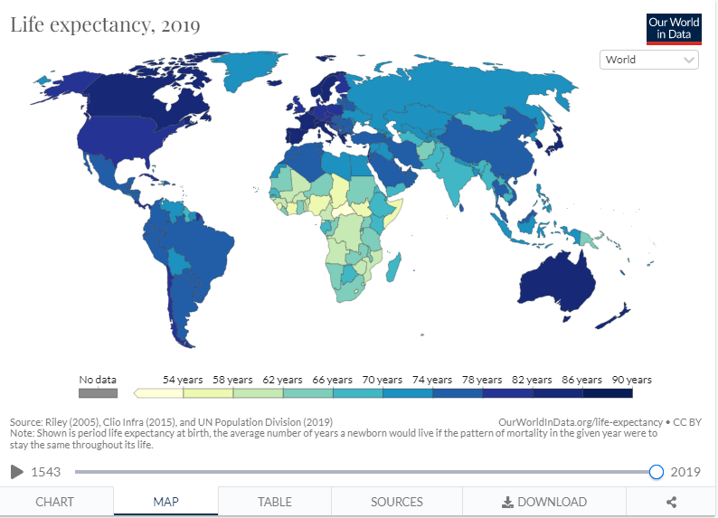



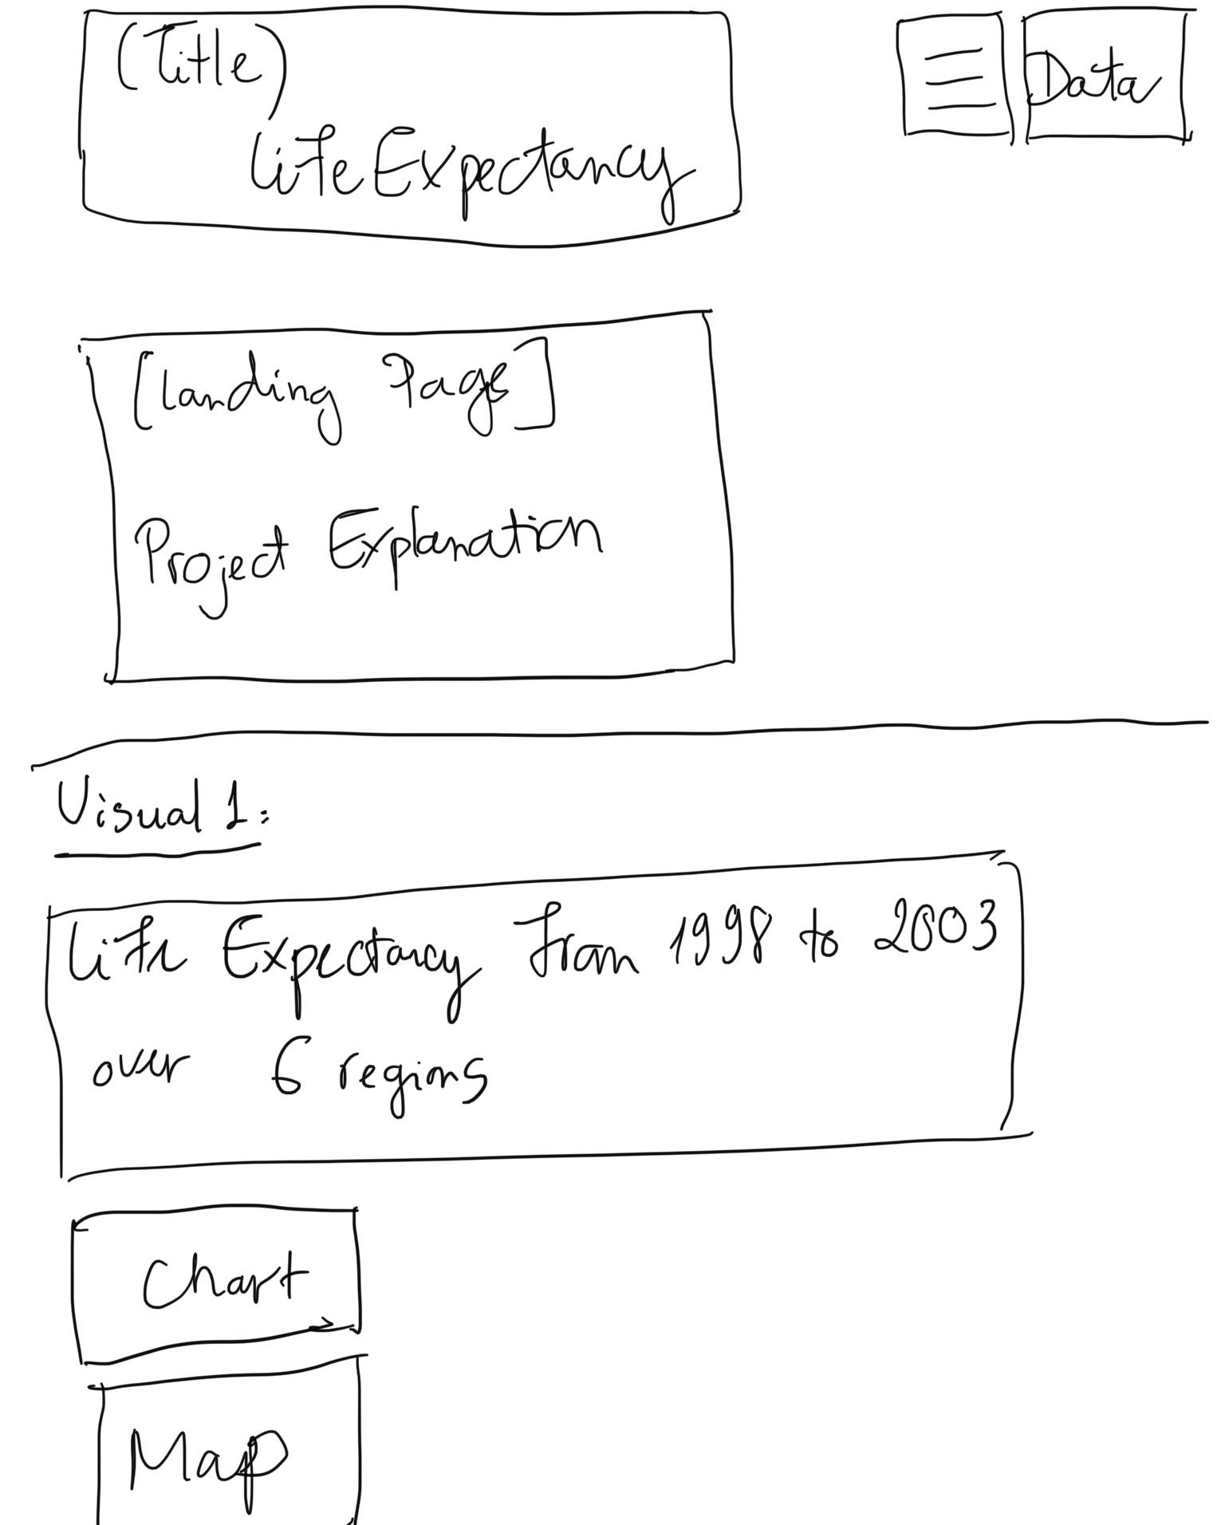

[](https://ourworldindata.org/life-expectancy#life-expectancy-and-gdp) Visual Three